ASSESSMENT TOOL 1 – High (Coding Challenge)

1. Bank Account System using Data Hiding
Design a BankAccount class with private fields accountNumber, holderName, and balance. Implement methods for deposit, withdrawal, and balance inquiry with proper validation. Prevent direct modification of balance from outside the class. Also, construct suitable test cases to validate valid and invalid transactions.
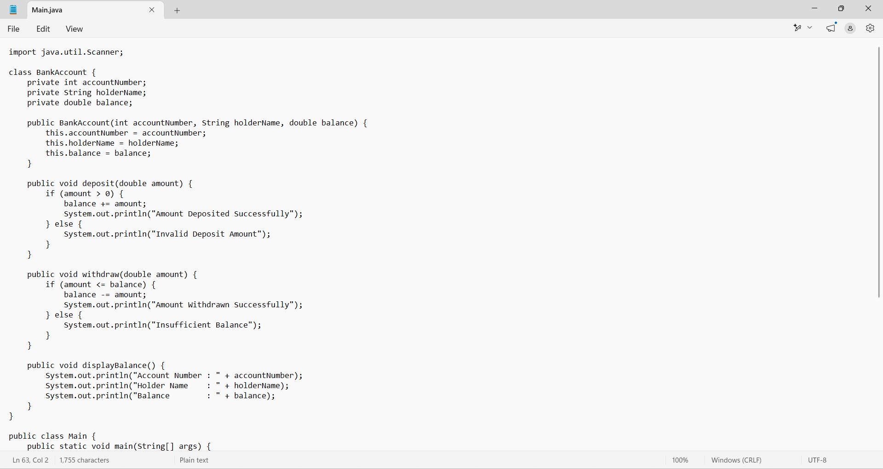

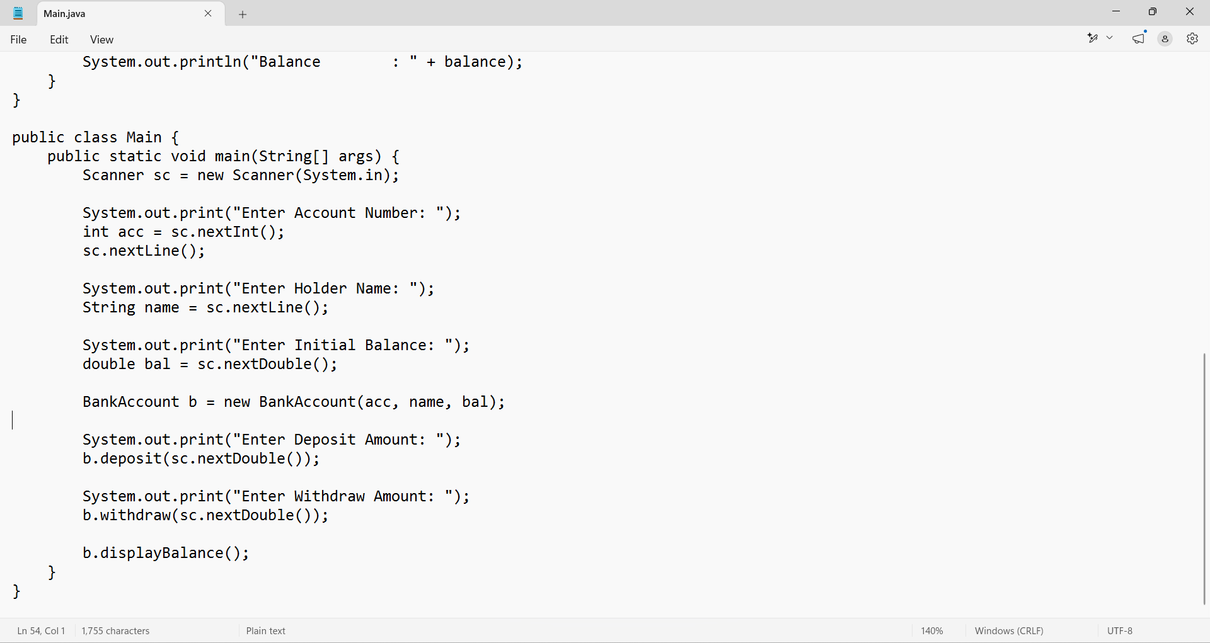

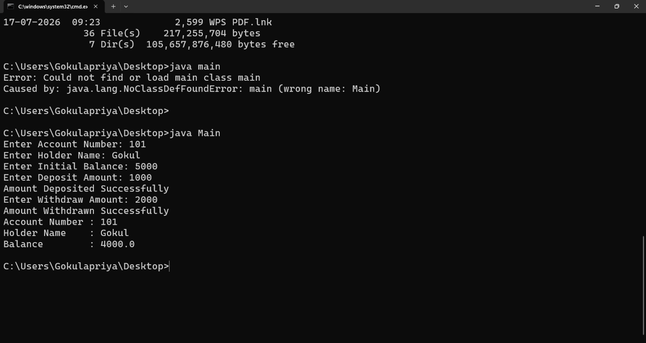

2. Employee Payroll System using Inheritance
Design a payroll system with a base class Employee and derived classes PermanentEmployee and ContractEmployee. Override a method calculateSalary() in each subclass to compute salary differently. Display employee details and salary using runtime polymorphism. Also, construct suitable test cases to validate salary calculation for different employee types.
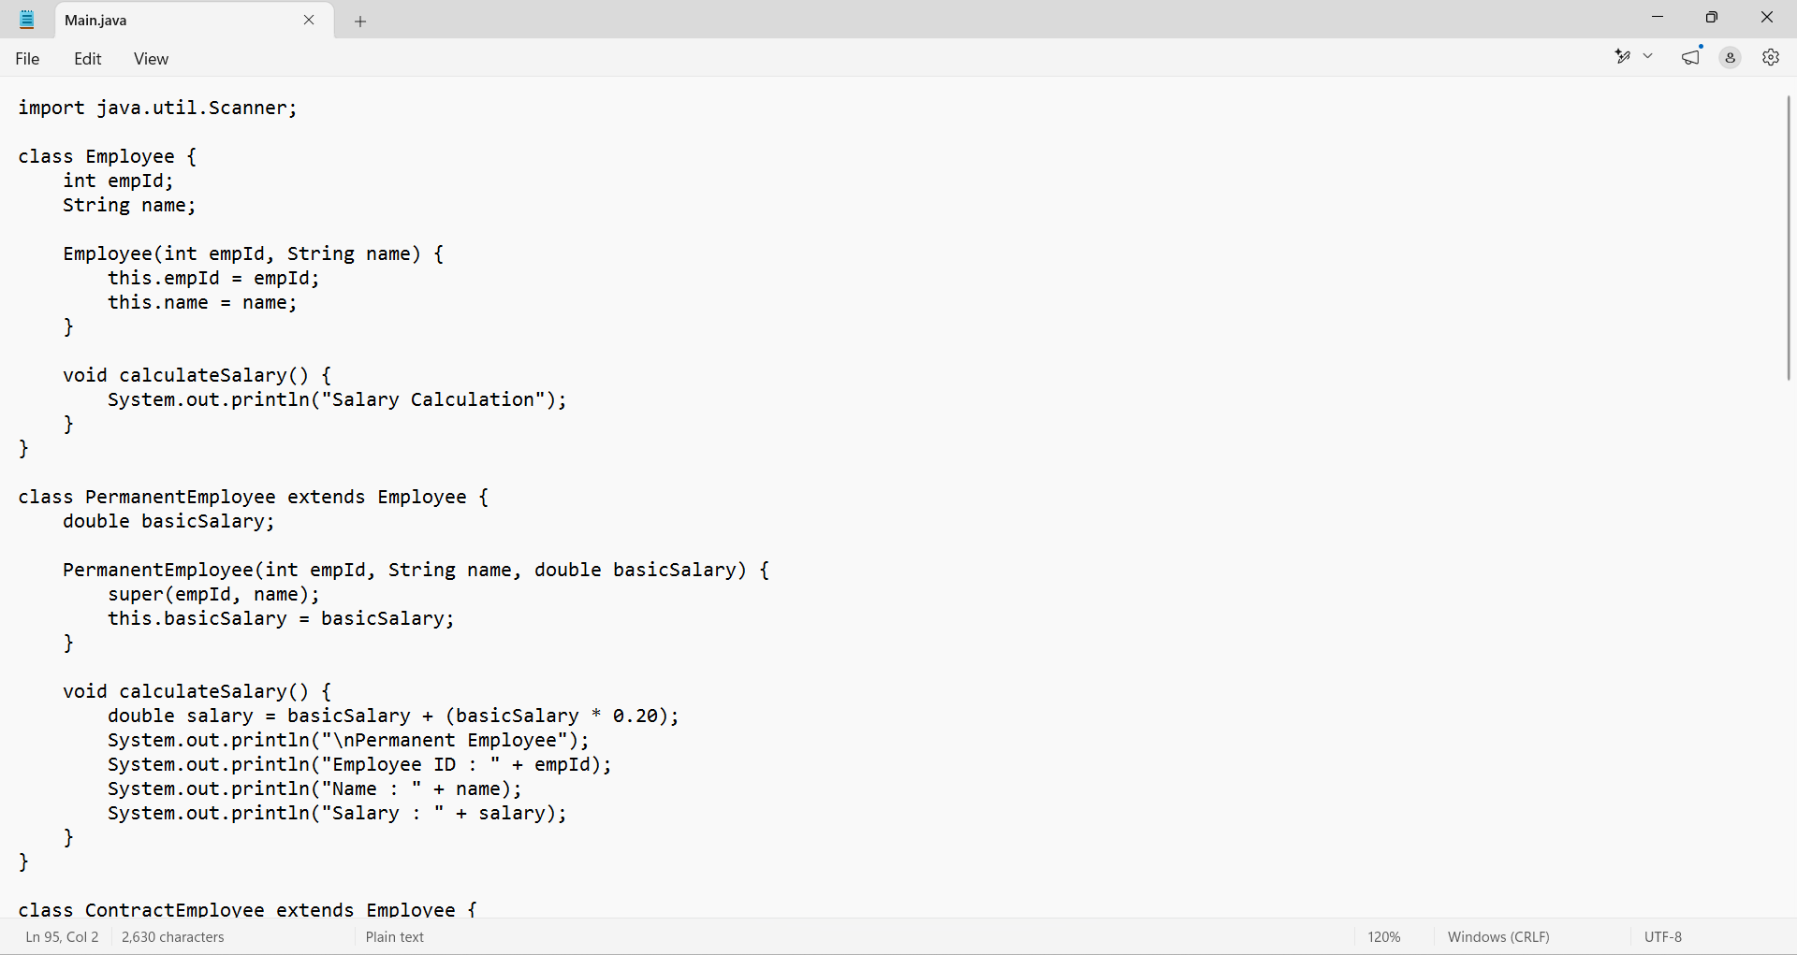

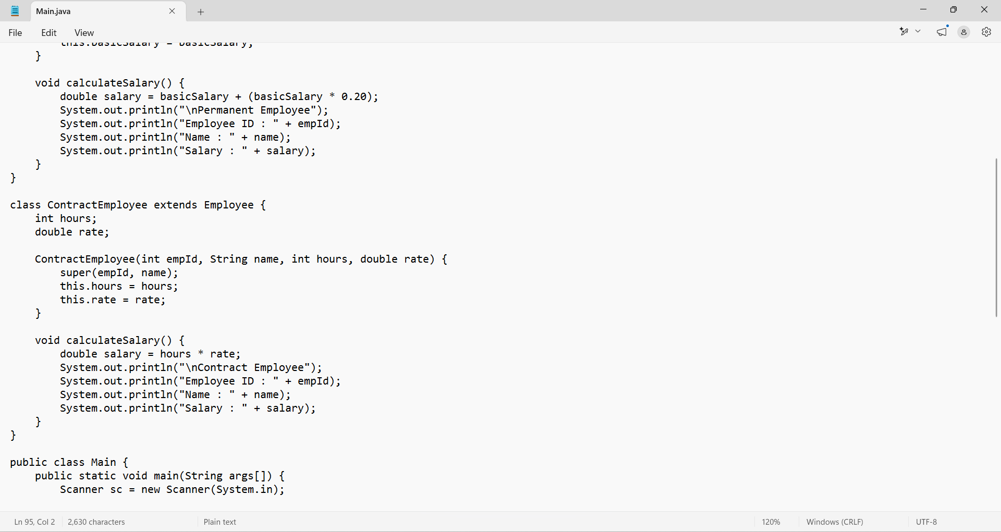
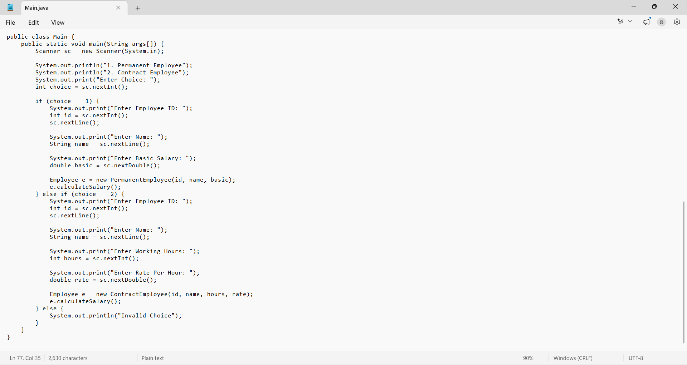

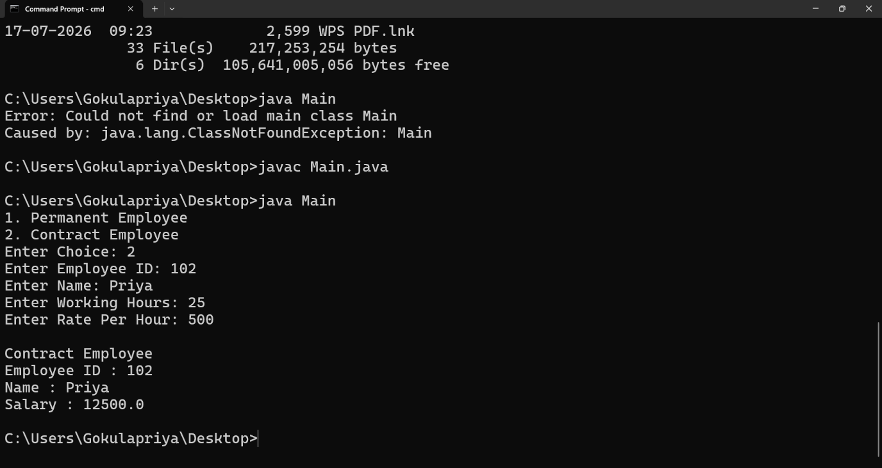

3.Shape Area Calculator using Abstract Class & Polymorphism
Design an abstract class Shape with an abstract method area(). Implement subclasses Circle, Rectangle, and Triangle. Use an array of Shape references to compute and display areas dynamically. Also, construct suitable test cases to validate area calculations and polymorphic behavior. BTL: BL4 (Analyze)
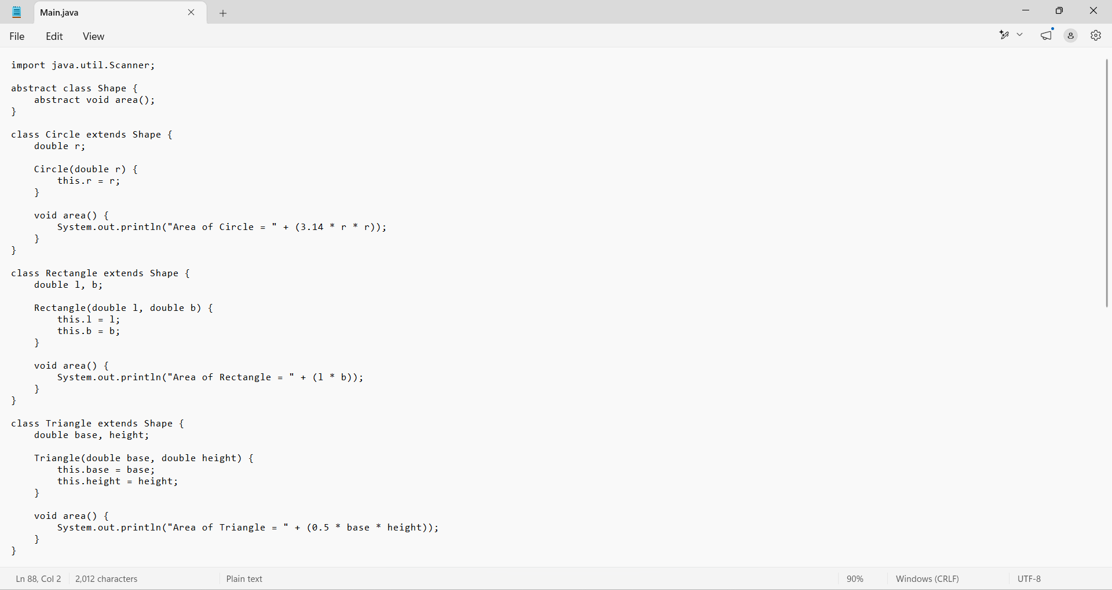
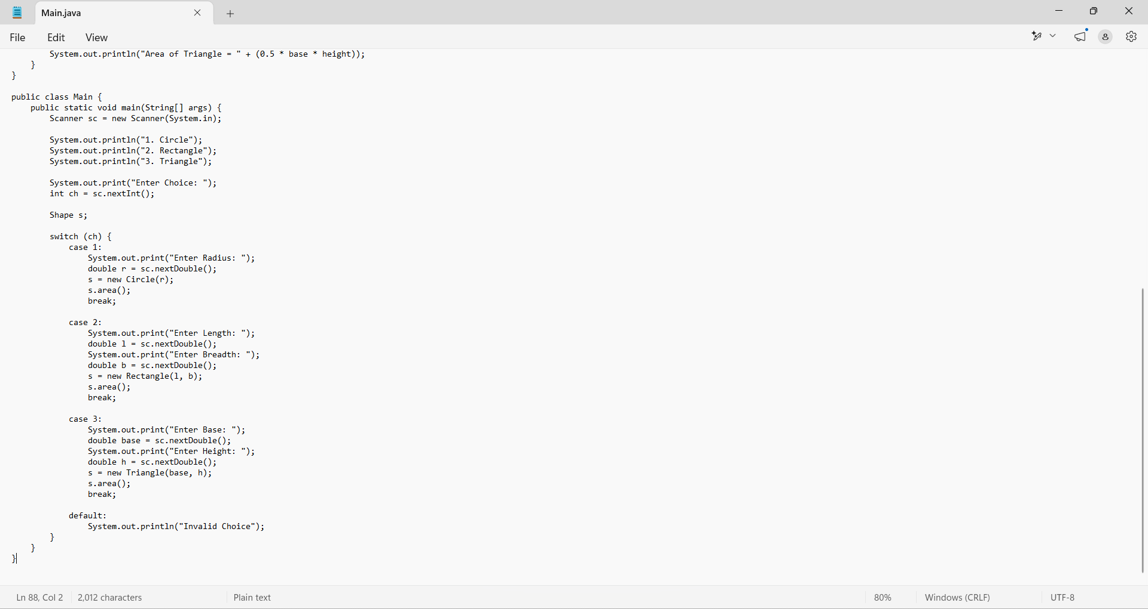
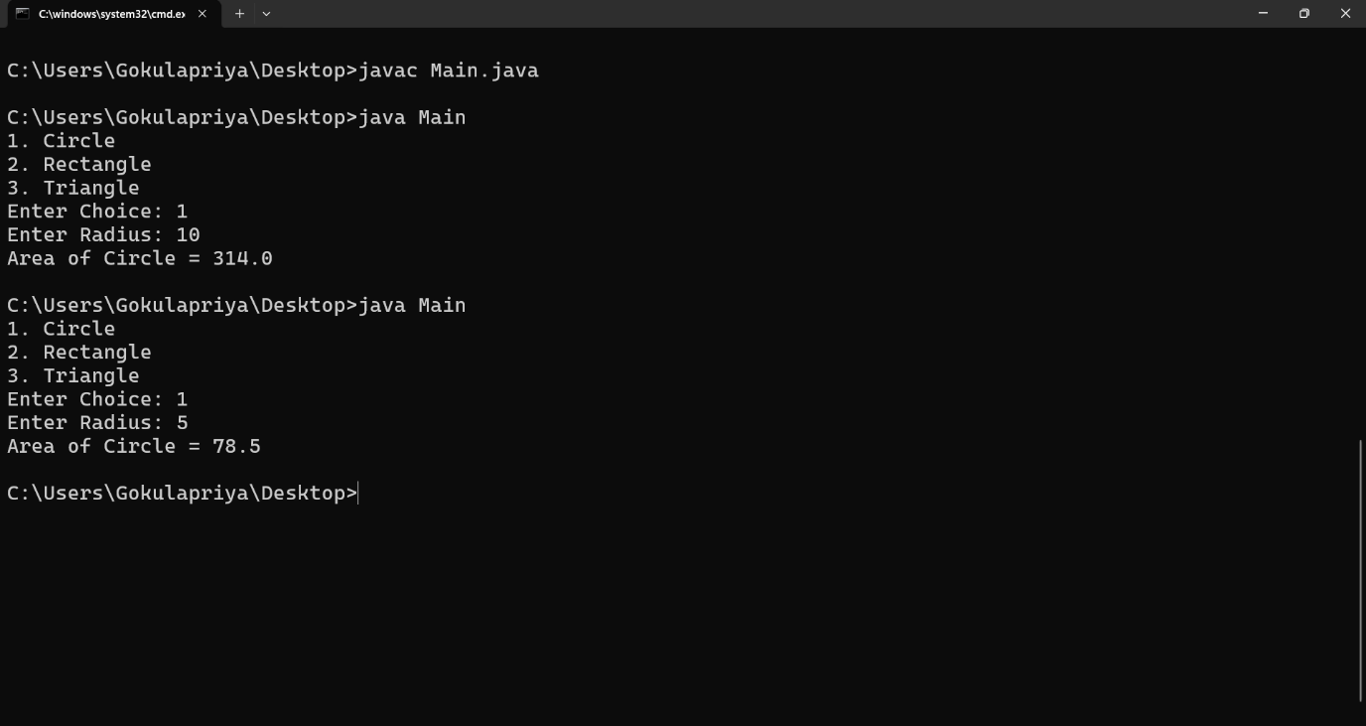

4. Library Book Management using Classes & Encapsulation
Design a Book class with private fields such as bookId, title, author, and price. Implement constructors, getters, setters, and methods to issue and return books. Create a menu-driven program to manage multiple books using an array of objects. Also, construct suitable test cases to validate book addition, issue, return, and search operations. BTL: BL3 (Apply)
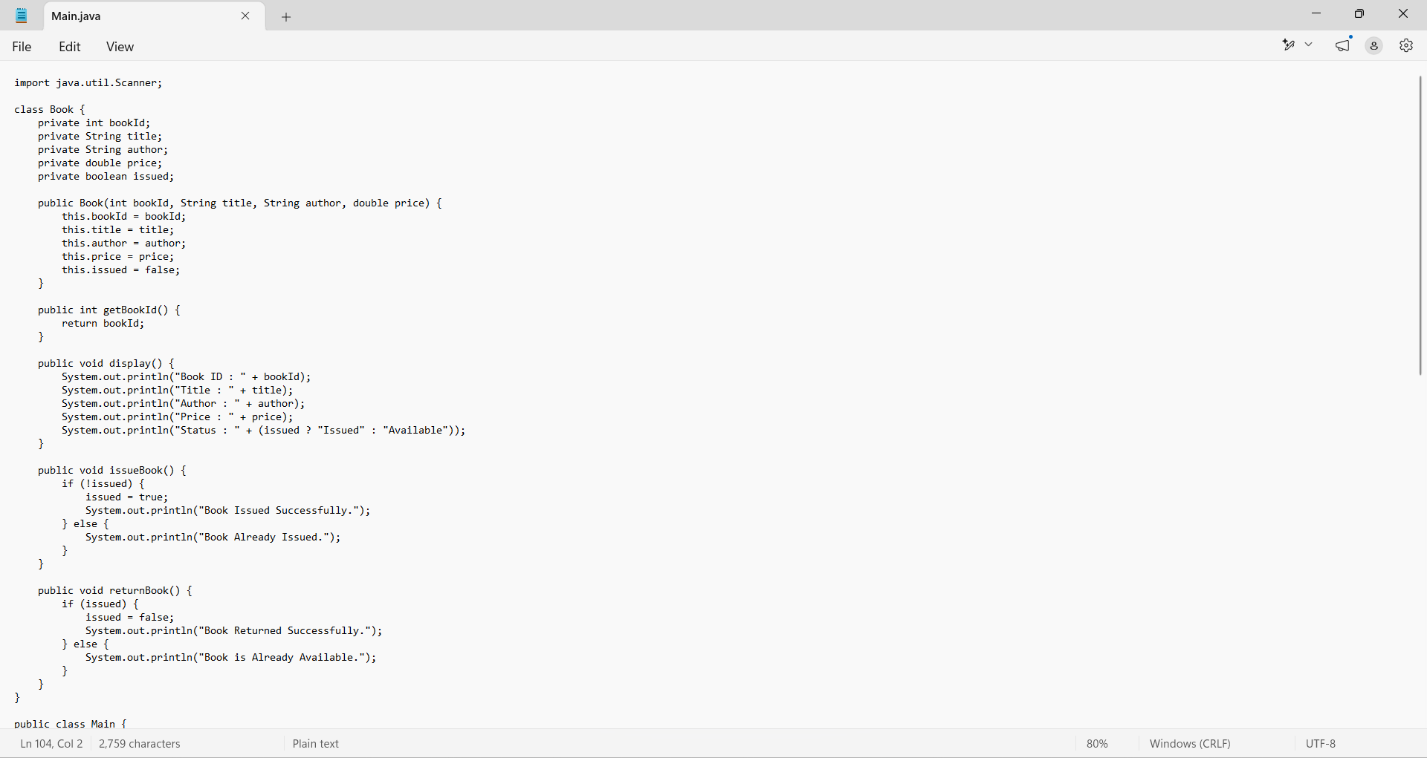
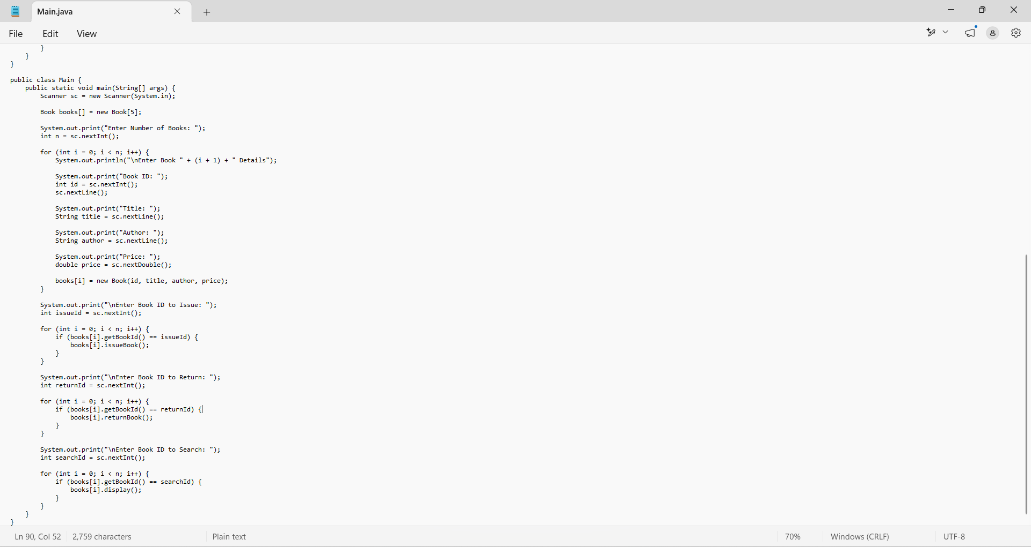

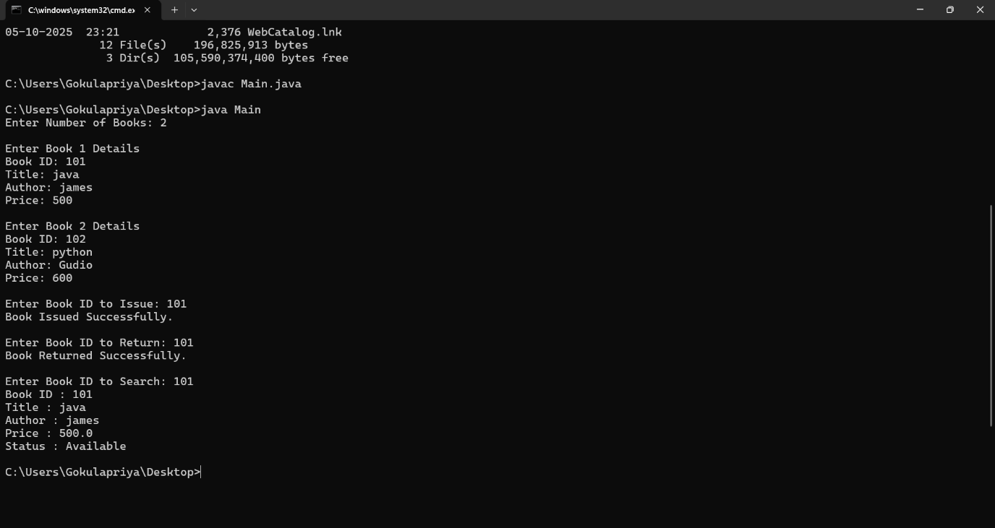

5. Student Result Analyzer using Arrays of Objects
Design a Student class containing roll number, name, and marks in three subjects. Store multiple student objects in an array and implement methods to calculate total, average, grade, and class topper. Also, construct suitable test cases to validate grading and topper identification. BTL: BL3 (Apply)
